**griefSpace**

Setup guide

1. **Introduction**

As this software has not been deployed, you will need to

1. install **XMAPP** to allow the application to run on a local server.
2. clone the software files from a GitHub repository and put them inside the *htdocs* folder.

Please click on the link below to find the video setup guide on YouTube:

<https://youtu.be/7d6nicD7PAk>

1. **Install XMAPP**



1. Users will need to install XMAPP to allow the application to run on a local server. The installation link can be accessed from the link below:

<https://www.apachefriends.org/>

1. Once the installation is completed, users can open the XAMPP Control Panel.
2. **Create necessary folder and place files in it**
3. After users install the **XMAPP**, users can then access the application’s repository to retrieve the files. The remote GitHub repository can be accessed from the link below:

<https://github.com/wcy692/griefSpace/tree/master>

The instruction below will assume users download a .zip file from the repository.

1. After downloading the files, please go to the **XMAPP** root folder. Alternatively, user can press the ‘Explorer’ button on the **XAMPP** Control Panel to open its root folder.

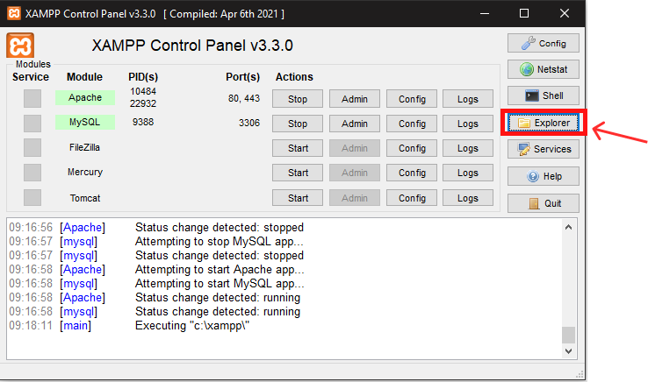

1. Once you are inside the root folder, open the *htdocs* folder.

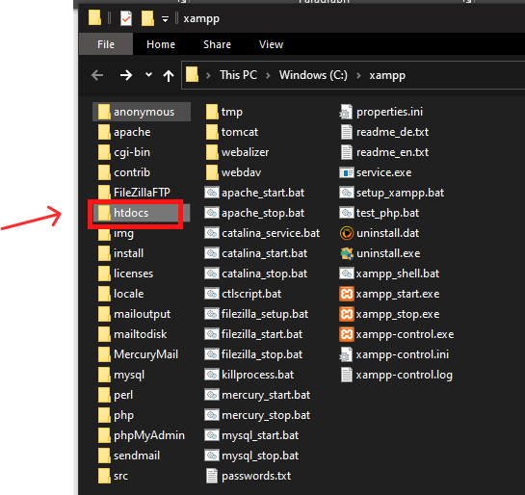

1. Once you are inside the *htdocs* folder, create a folder called *griefSpace* and enter the *griefSpace* folder*.*
2. Once you are inside the *griefSpace* folder, open the .zip file that you have downloaded. Then drag all the files and folders of the zip files to the *griefSpace* folder.
3. **Access MySQL and import database**
4. After you have local files set up, go to **XMAPP** control panel and start Apache and MySQL.

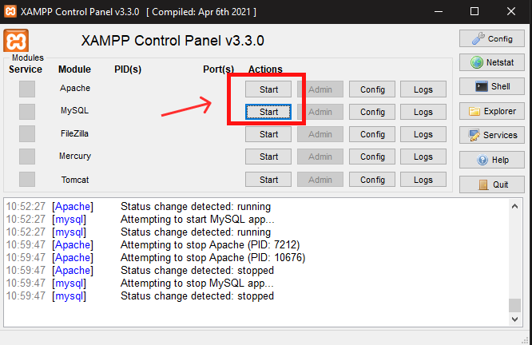

1. Press the ‘Admin’ button of the MySQL to open **Phpmyadmin**

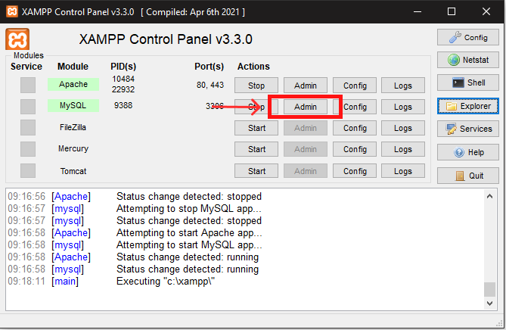

1. Once you are on the Phpmyadmin page, press “New” to create a database.

1. Enter “griefspace” as the new database name and click create.

1. Click “griefspace” to enter this database, then click import.
2. Once you are on the import section, click on the “choose file” button.

1. Open the sql file griefspace.sql inside the doc folder and press “Go” to import all the tables. The griefspace.sql file can be found inside the doc folder which is under the htdocs folder. The example path of the griefspace.sql file will be /xampp/htdocs/doc/griefspace.sql

1. **Access griefSpace web page**
2. Once you finish all the previous steps, start the Apache and click on the ‘Admin’ button on the XAMPP control panel to access the localhost.

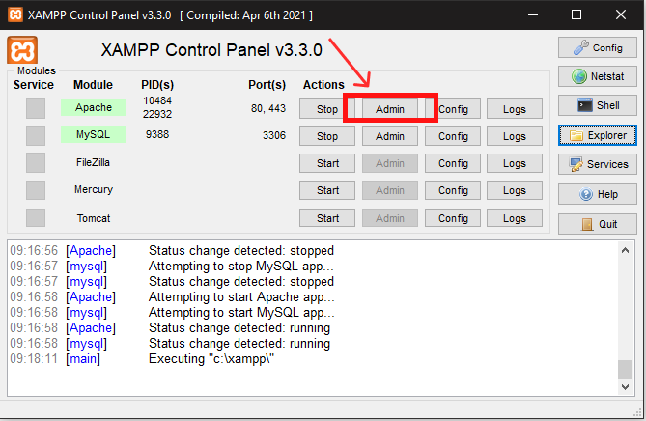

1. Navigate to the griefSpace folder and you should be able to enter the index page of the website.

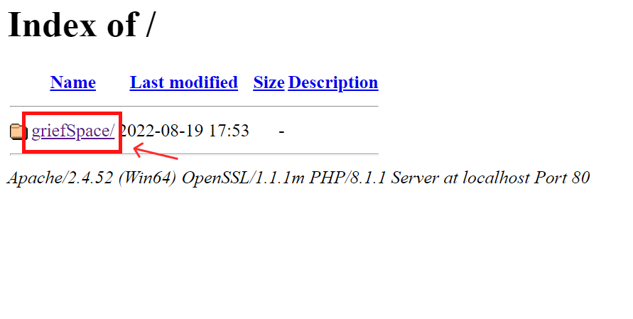

1. From this step onwards, you can examine all the features on the web page. We recommend you to first register an account by entering username, email and password. A valid email address is recommended as the application will send email to this address.
2. From now on, your databases and local files are set and ready to launch. If you are interested in a detailed illustrations on features and systems, please read the document named ‘Brief introduction on features and the logic’.

A video demonstrating systems and features can be accessed on YouTube:

<https://youtu.be/lQV3LUSwLek>